### Run The Web Application

|  |  |
| --- | --- |
| Date | 08th July 2024 |
| Project Title | AI Feedback Generator For Development Teams Using Palm's Text-Bison-001 |

**CODE:**

* Open the anaconda prompt from the start menu
* Navigate to the folder where your Python script is.
* Now type “streamlit run app.py” command
* Navigate to the localhost where you can view your web page

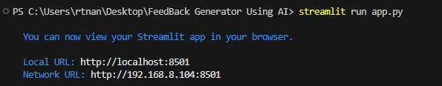

**OUTPUT:**

**Now, the application will open in the web browser.**

